Oracle Database 11.2.0.1 Installation steps:

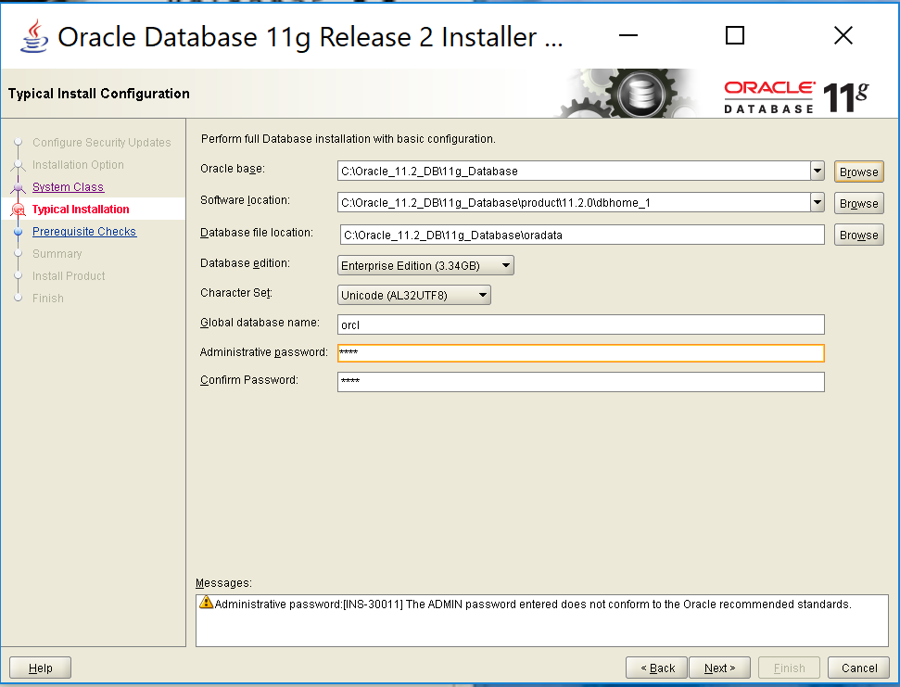

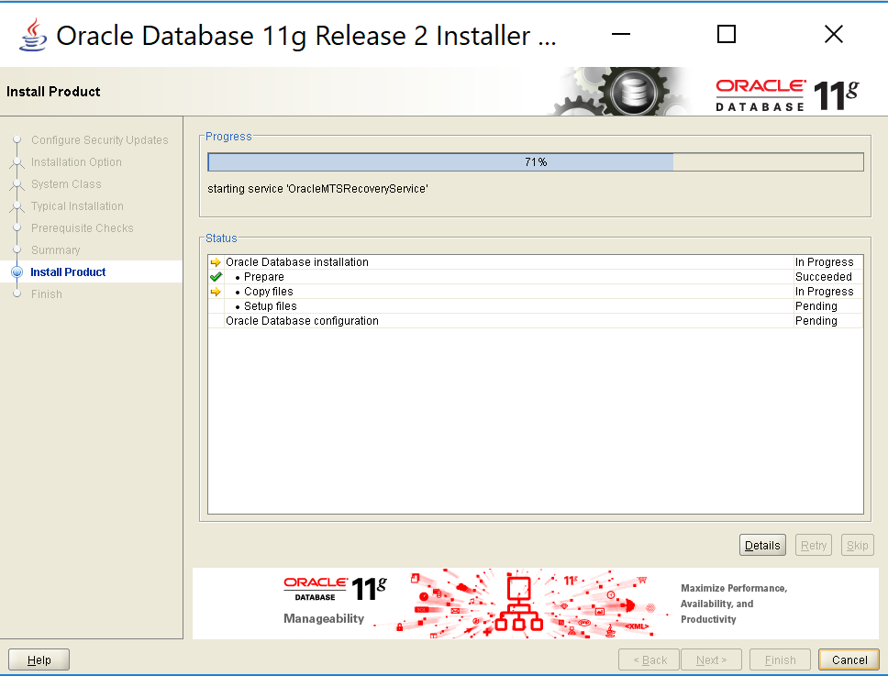

Installation details:

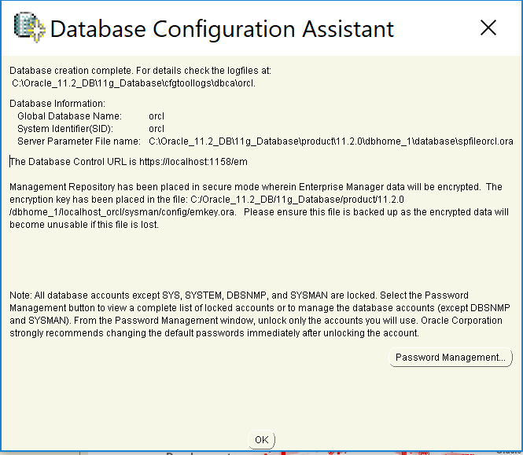

Unlock all the Accounts and create passwords for :

User Name: SYS ; password : SYS

User Name SYSTEM ; Password: SYSTEM

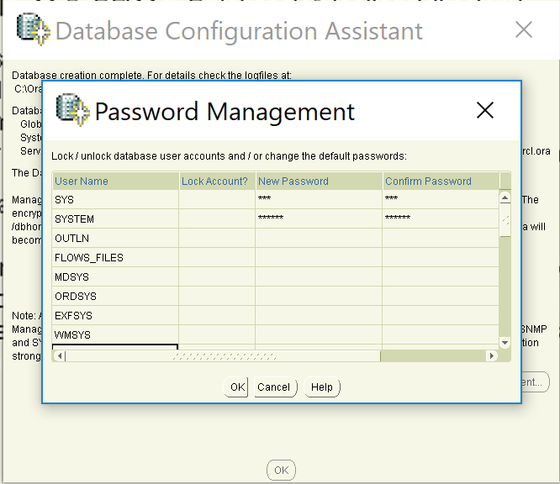

**Note:**

**Enterprise Manager Database Control URL - (orcl) :**

[**https://localhost:1158/em**](https://localhost:1158/em)

**SET ENVIRONMENTAL VARIABLES:**

**To configure operating system environment variables for your database instance on Windows systems:**

1. Open an operating system command window.
2. Use either regedit or the Oracle Administration Assistant for Windows to make sure the ORACLE_HOME and ORACLE_SID parameters are set to the correct values in the HKEY_LOCAL_MACHINE\SOFTWARE\ORACLE\KEY_HOME_NAME registry subkey.
3. Ensure that the %ORACLE_HOME%\bin directory is in your PATH environment variable. At a command prompt, use a command similar to the following:

set PATH=%ORACLE_HOME%\bin;%PATH%

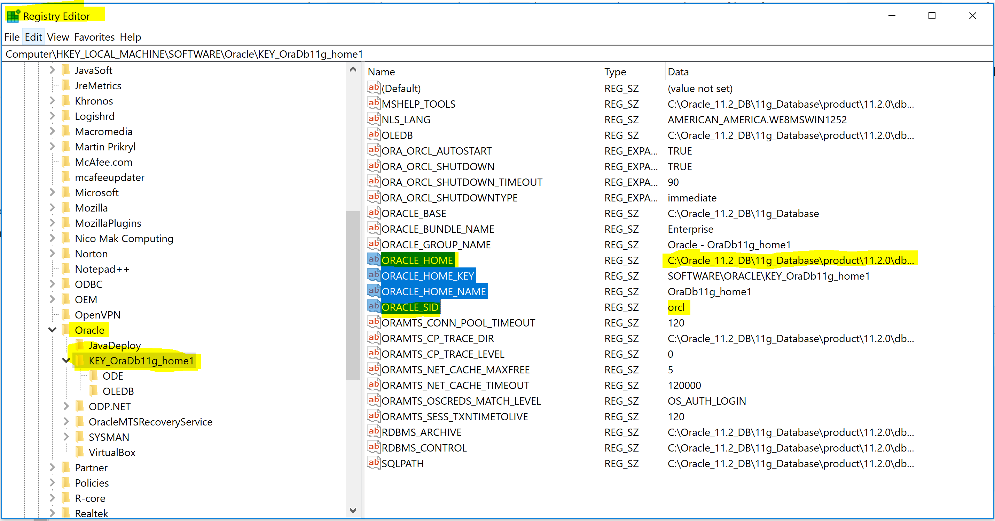

**Note:** Make sure ORACLE_HOME AND ORALCE_SID; Paths are same in “regedit” (Registry Editor) and Environmental Variables.

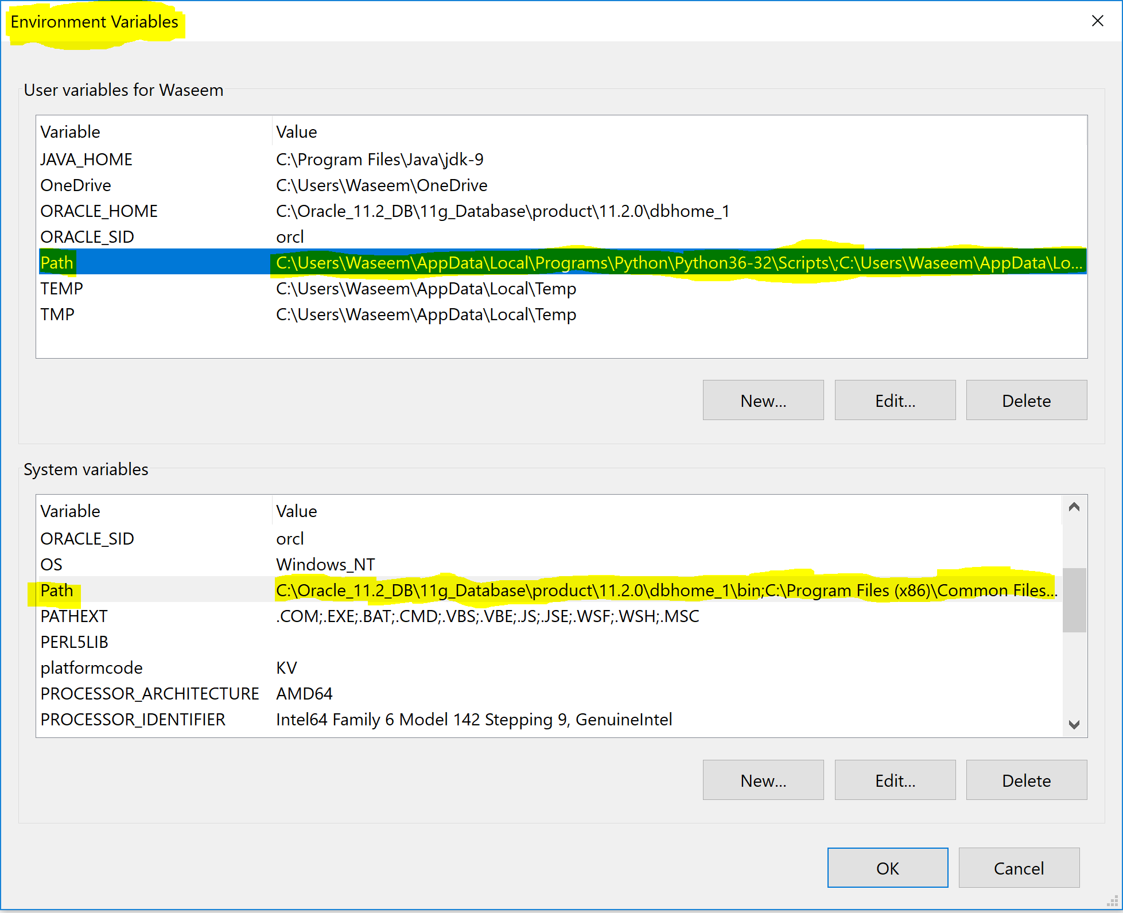

Your database configuration files have been installed in C:\Oracle_11.2_DB\11g_Database while other components selected for installation have been installed in C:\Oracle_11.2_DB\11g_Database\product\11.2.0\dbhome_1. Be cautious not to accidentally delete these configuration files.

2. After Installation configure the Oracle Listener: Go to Oracle Net Configuration Assistance and Congifure Listener

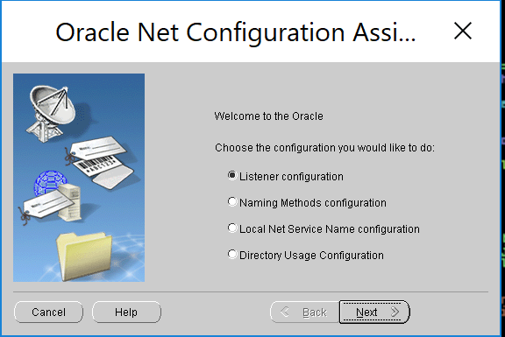

**Note: It is not required if it is already configured. Check status using cmd “lsnrctl status listernerName” as Shown below**

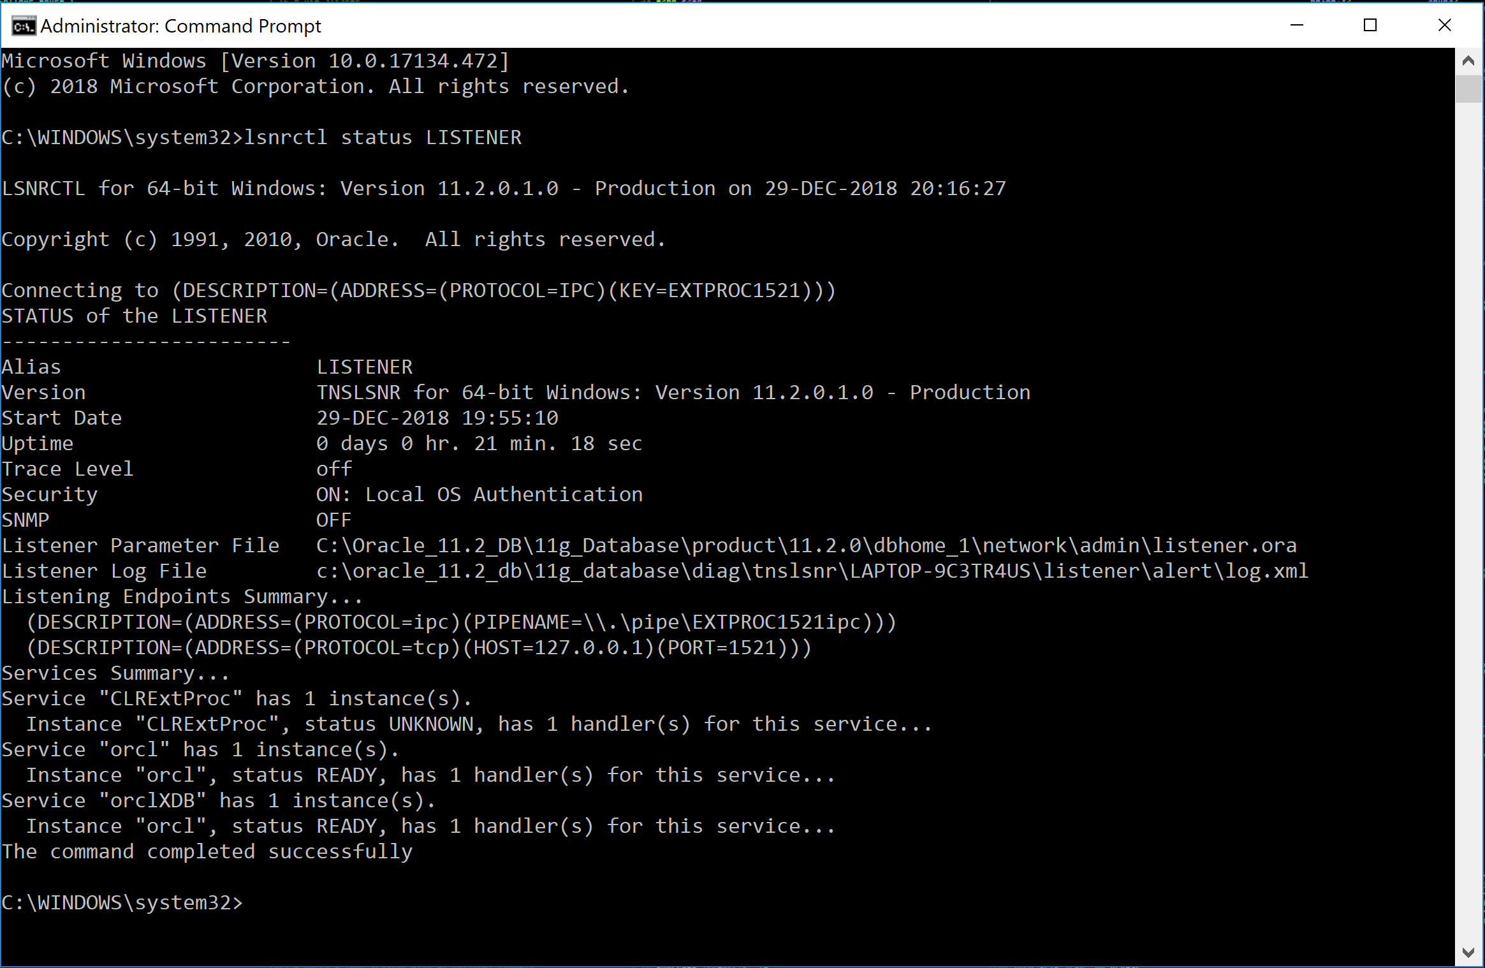

**Next Setup Database: Use Database Configuration Manager**

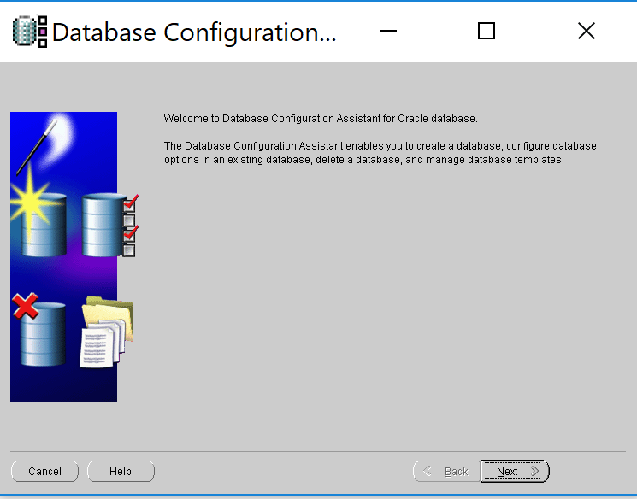

Create a General purpose or Transaction Processing Datafiles

Global Database Name: “ORCL”

SID: “ORCL”

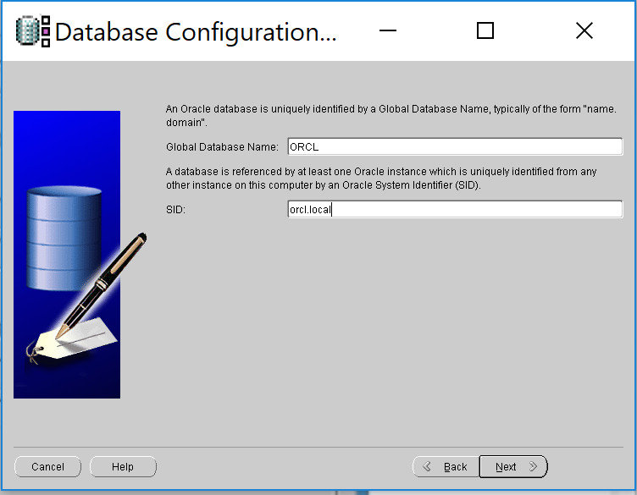

If you want another DB with same Database name, we can use different SID with same DB name to clone the current DB.

**Next Setup Local net service Name Configuration:**

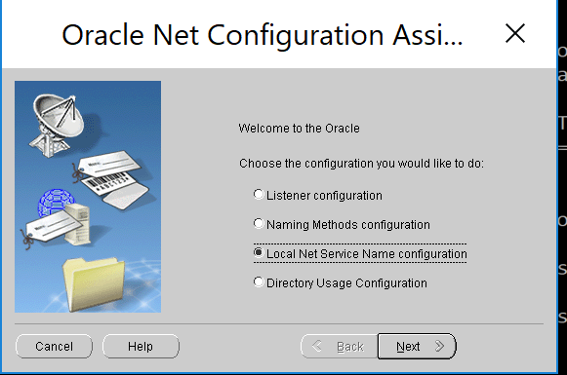

**With Service Name: “ORCL”**

**Next - - DataBase To access TCP**

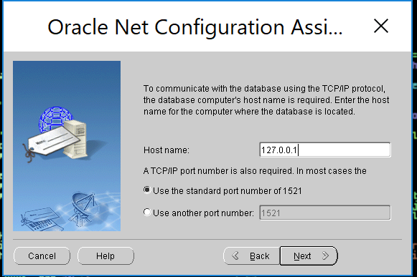

**Test the connection:**

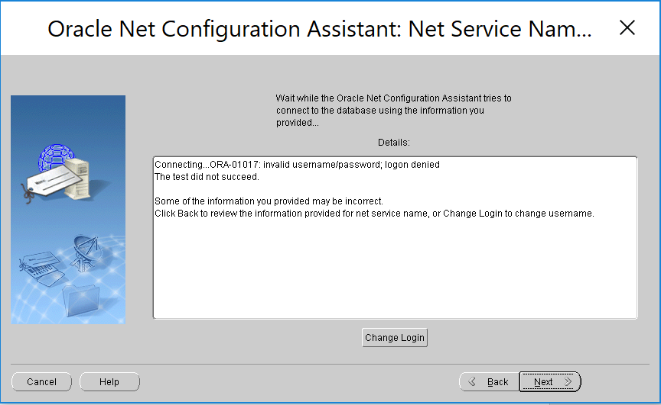

**Error:** This is because I haven’t configured the Database yet.

Required thing todo: Oracle will take default SYSTEM password, so change it to the required password.

**User Name: system**

**Password: system**

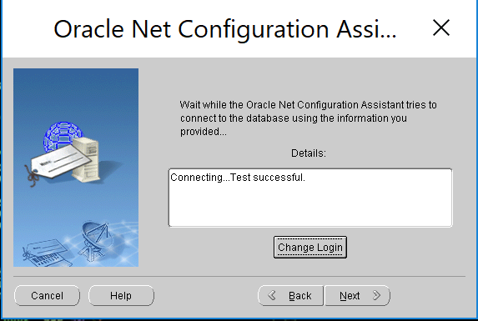

**Question:**I need to understand how the oracle_unqname environmental variable works in 11g.

**Answer:**The *oracle_unqname* an OS environmental variable that defines the database unique name.  The *oracle_unqname* is used in 11g and beyond to enable OEM.  You can see this value with this query:

select   
   name,   
   db_unique_name   
from   
   v$database;

If you have not defined oracle_unqname you will see this error when starting OEM:  
  
C:\> emctl status dbconsole   
  
Environment variable ORACLE_UNQNAME not defined.   
Please set ORACLE_UNQNAME to database unique name   
  
  
Here is hot to set oracle_unqname in Windows.  You use a similar "export command" in UNIX/Linux:

C:\>set ORACLE_HOSTNAME=localhost  
  
C:\>set ORACLE_UNQNAME=orcl  
  
C:\>set ORACLE_SID=orcl   
  
C:\>emctl status dbconsole  
  
Oracle Enterprise Manager 11g Database Control Release 11.2.0.1.0  
Copyright (c) 1996, 2015 Oracle Corporation. All rights reserved.

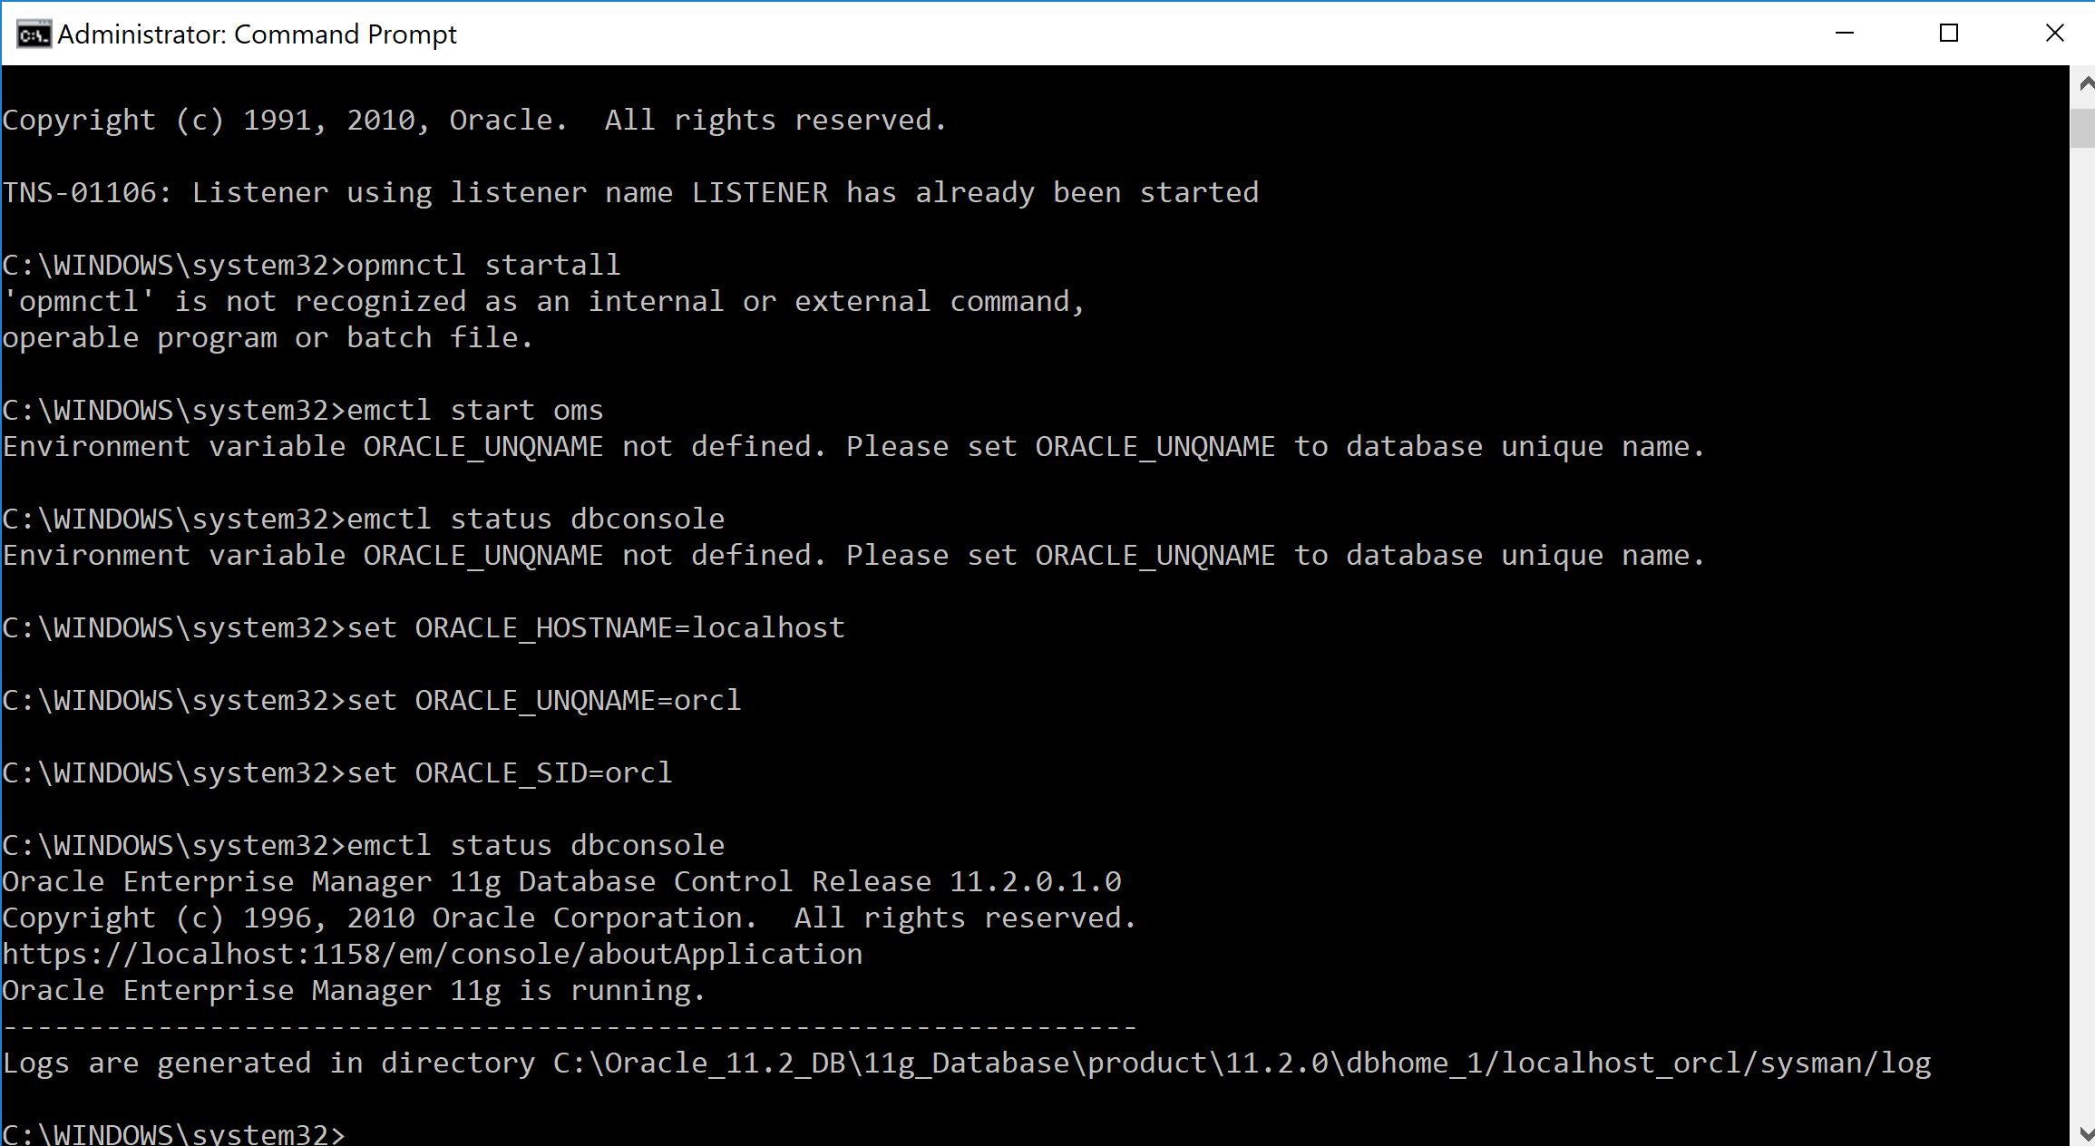

**Below are the commands to start the Management services:**

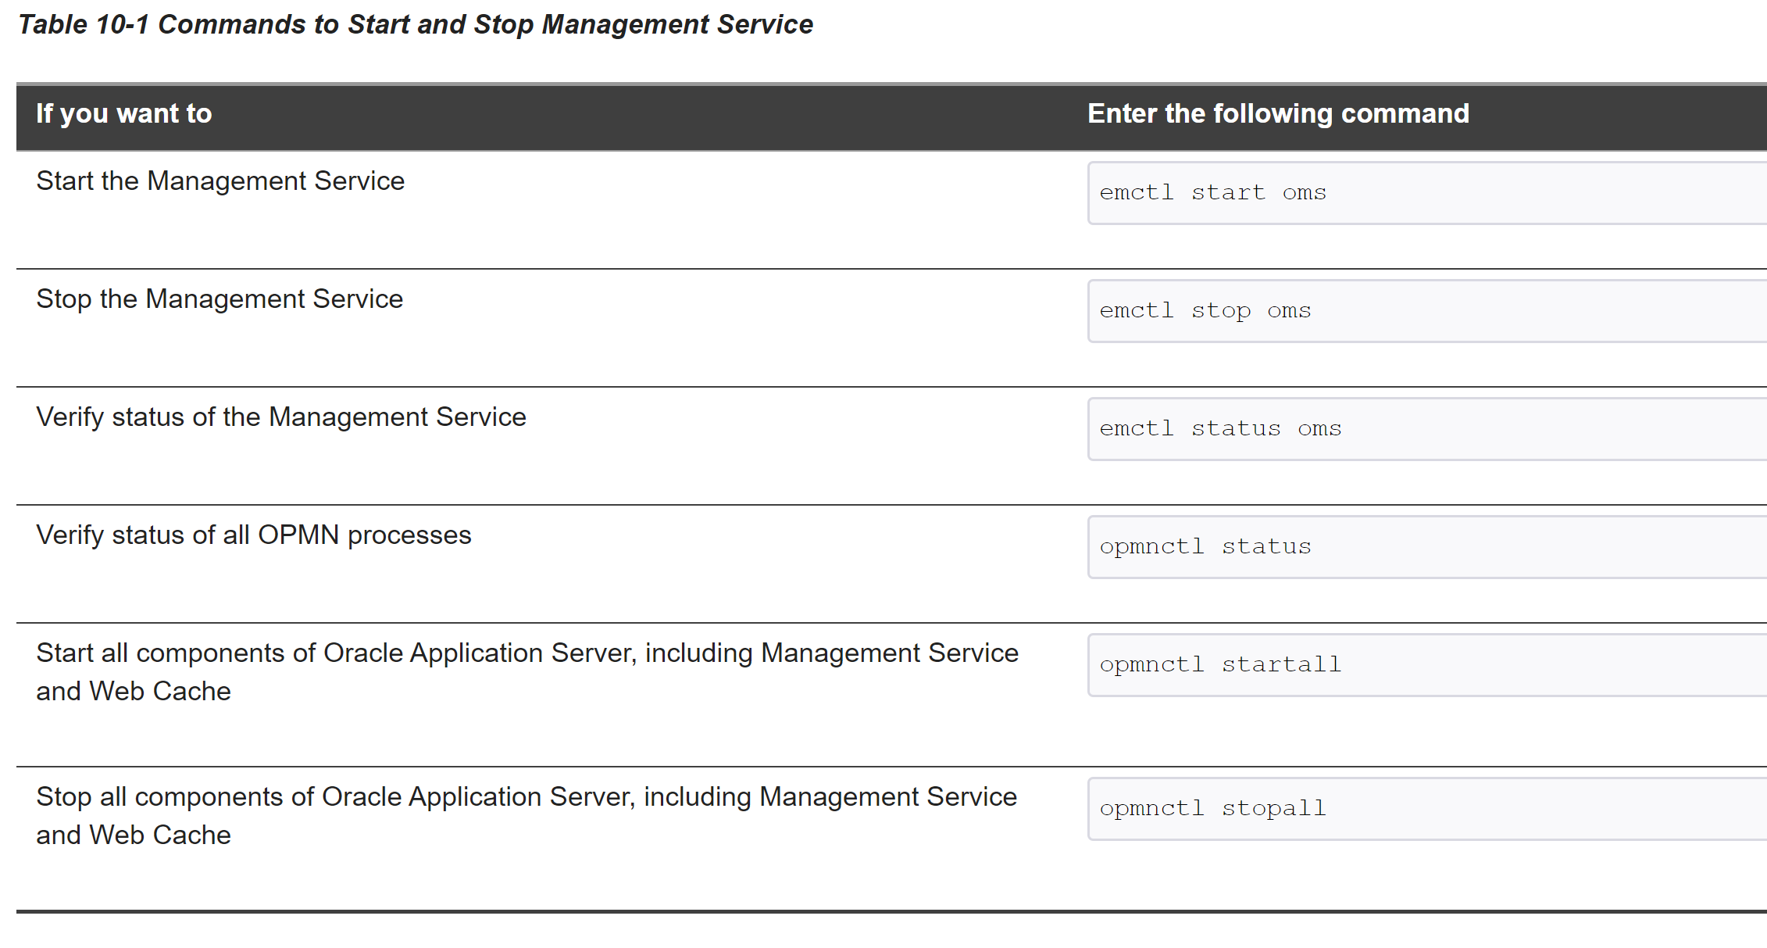

opmnctl

**opmnctl** is the supported tool for starting and stopping all components in an Oracle instance, with the exception of the Fusion Middleware Control Console. **opmnctl**provides a centralized way to control and monitor system components from the command line.

If OPMN is configured to discover other Oracle instances, you can use **opmnctl** to execute control and monitoring commands across multiple Oracle instances simultaneously.

The location of the opmnctl script determines which opmnctl commands you can use.

The **opmnctl** command exists in two distinct directory location paths:

* ***ORACLE_HOME*/opmn/bin/opmnctl**: The **opmnctl** command ***ORACLE_HOME*/opmn/bin/opmnctl** location can only be used to create an Oracle instance or a component for an Oracle instance on the local system. **opmnctl** commands generated from this location cannot be used to manage system processes
* ***ORACLE_INSTANCE*/bin/opmnctl**: The other **opmnctl** command which is located in the ***ORACLE_INSTANCE*/bin/** directory location provides a per Oracle instance instantiation of **opmnctl**. The **opmnctl** command in this location must be used for managing processes for this Oracle instance and can also be used for creating components for the Oracle instance.

**Further:** [**https://docs.oracle.com/cd/E15523_01/doc.1111/e14007/opmnctl.htm#i1031273**](https://docs.oracle.com/cd/E15523_01/doc.1111/e14007/opmnctl.htm#i1031273)

**Document on OEM Agent:** [**http://www.dba-oracle.com/t_restart_oem_agent.htm**](http://www.dba-oracle.com/t_restart_oem_agent.htm)

**Error on Enterprise Manager is not able to connect to the DB instance:** [**http://www.dba-oracle.com/t_enterprise_manager_unable_to_connect_to_db_instance.htm**](http://www.dba-oracle.com/t_enterprise_manager_unable_to_connect_to_db_instance.htm)

Database Connection details:

User Name: oracle

Password: oracle

Port number: 49908

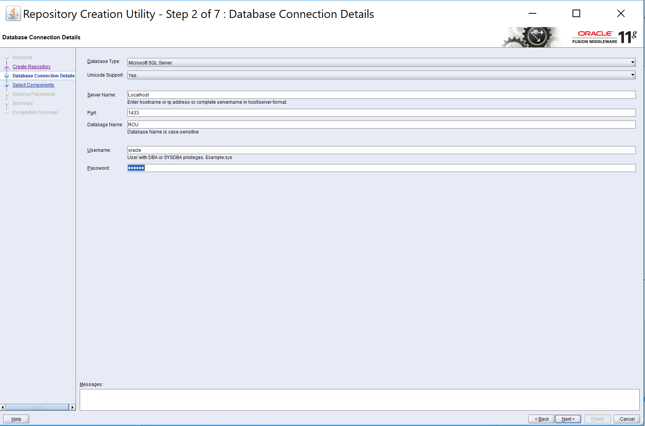

To know the Port number use:

Open Run in your system

Type %windir%\System32\cliconfg.exe

Click on ok button then check an TCP ip pop-up is open

Highlight TCP/IP under the Enabled protocols window.

Click the Properties button.

Enter in the new port number, then click OK.

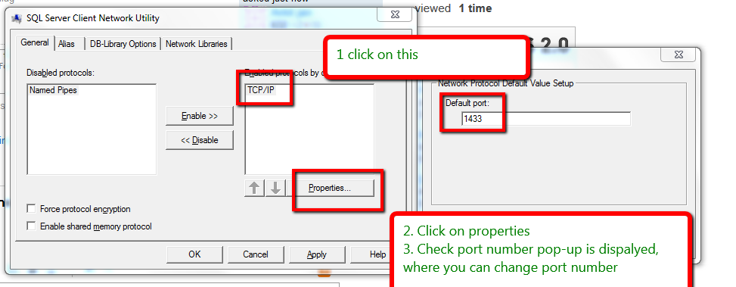

Create a SYS login:

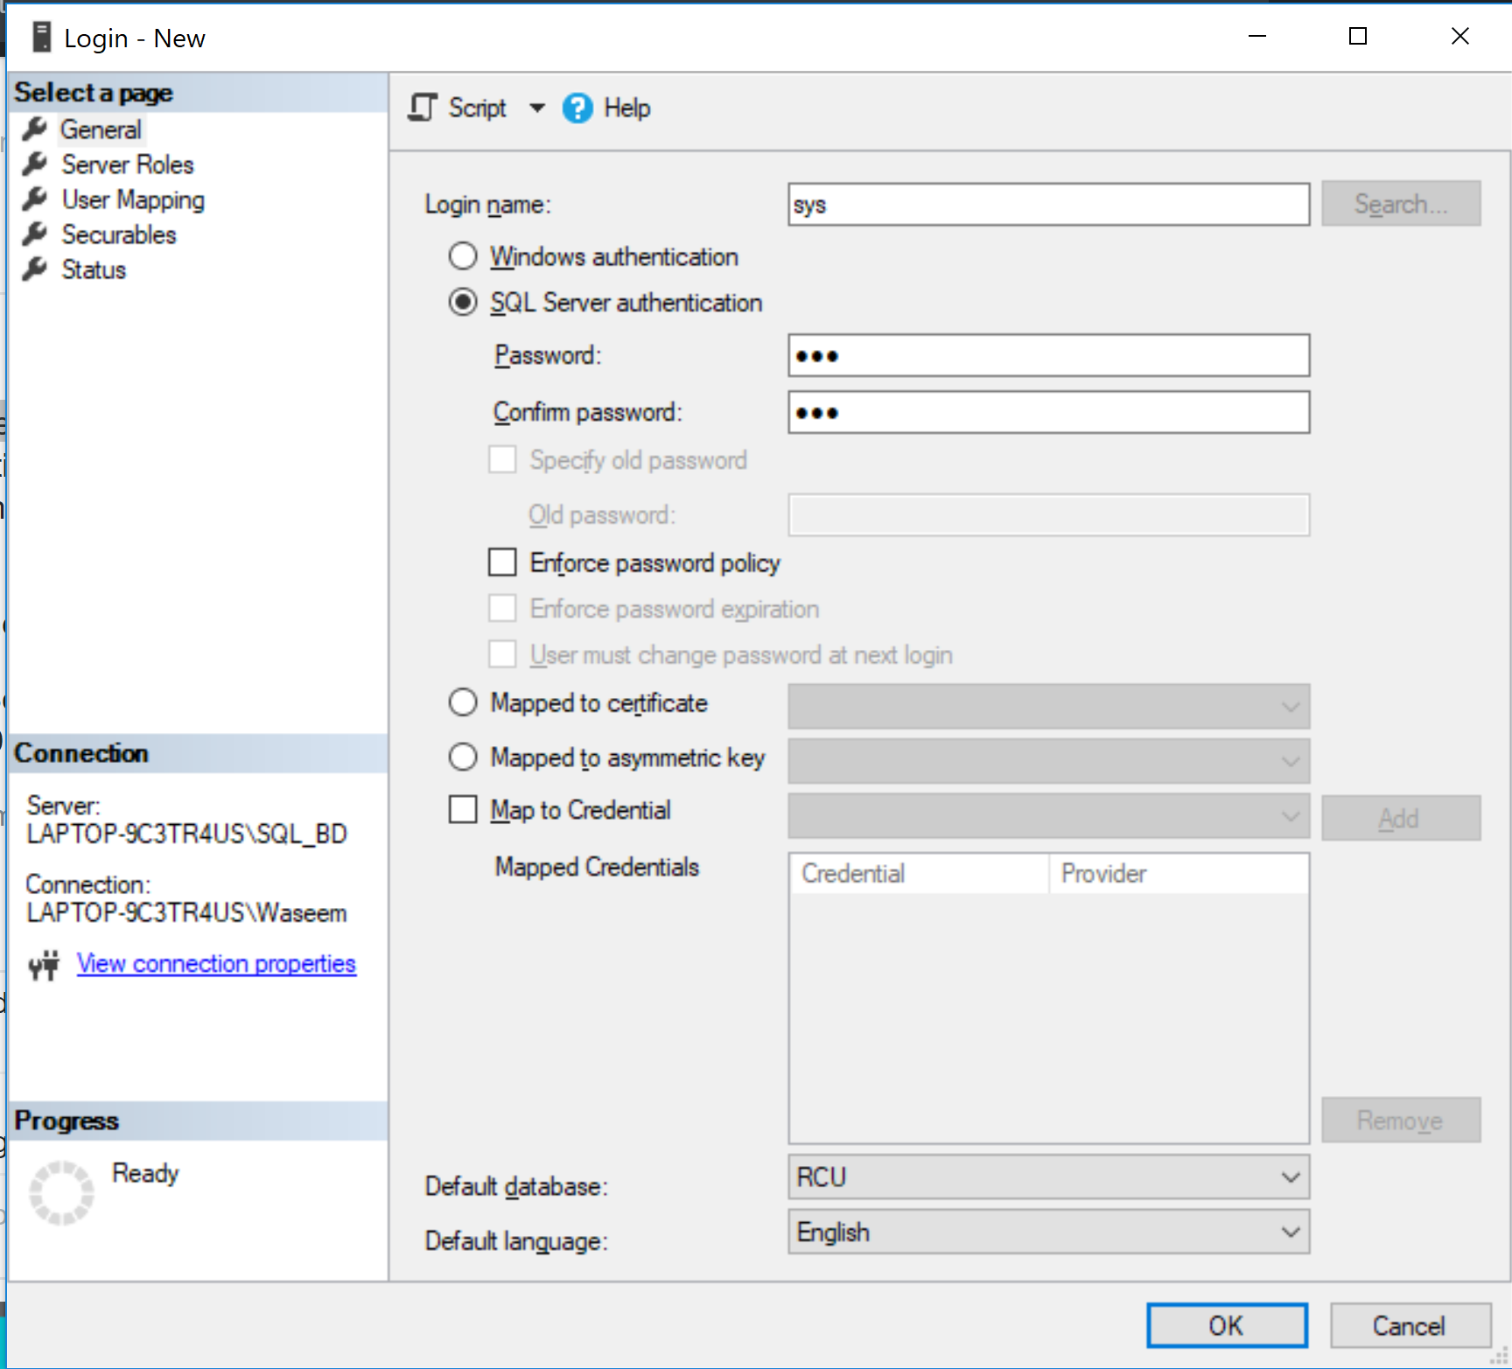

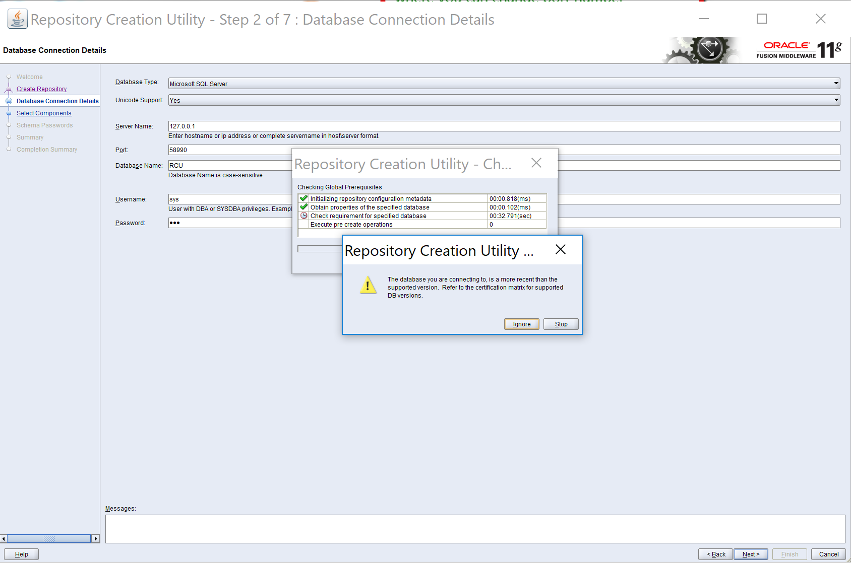

**Note: Use Oracle DB 11.2.0.1 and try again as SQL server lastest version doesn’t work!**

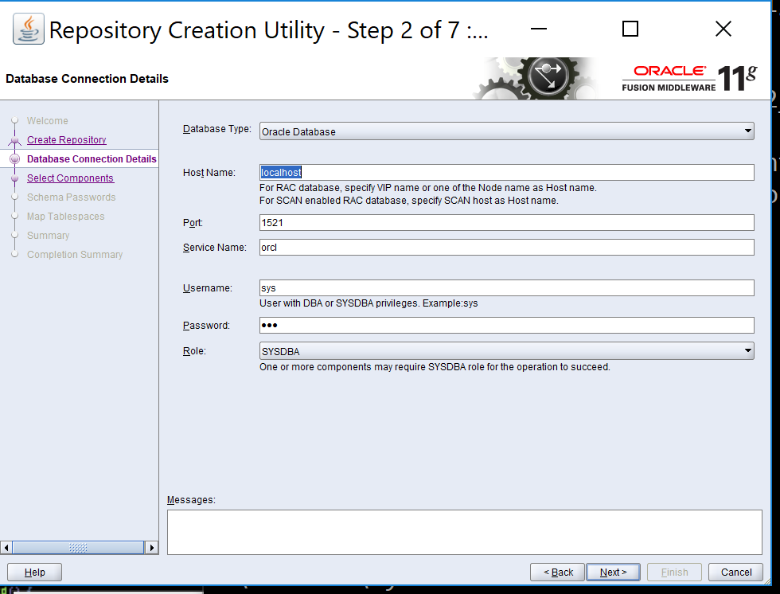

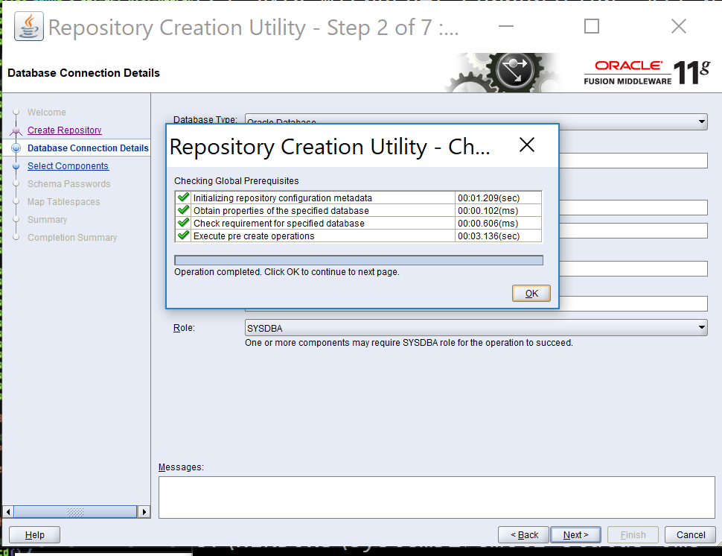

**Note :** Under the Components Select DEV_MDS and DEV_BIPLATFORM and click next.

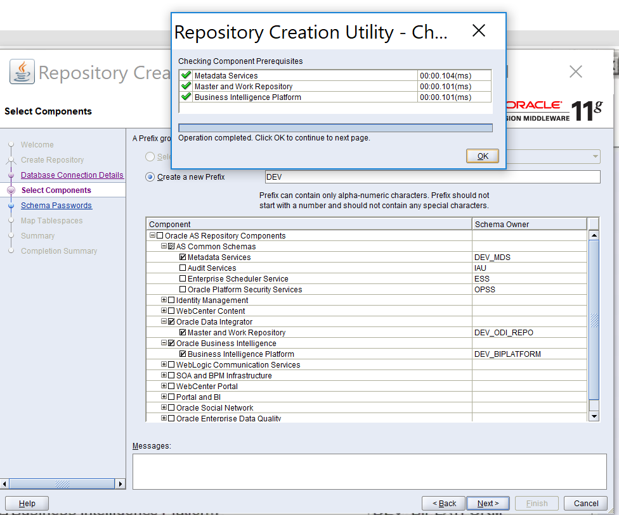

**\*\*NOTE:** You can either give the same password for all the schemas or specify different passwords. In my case, I have chosen the same passwords for all the schemas. Click Next

**Note:** Password for all schemas is: **welcome1**

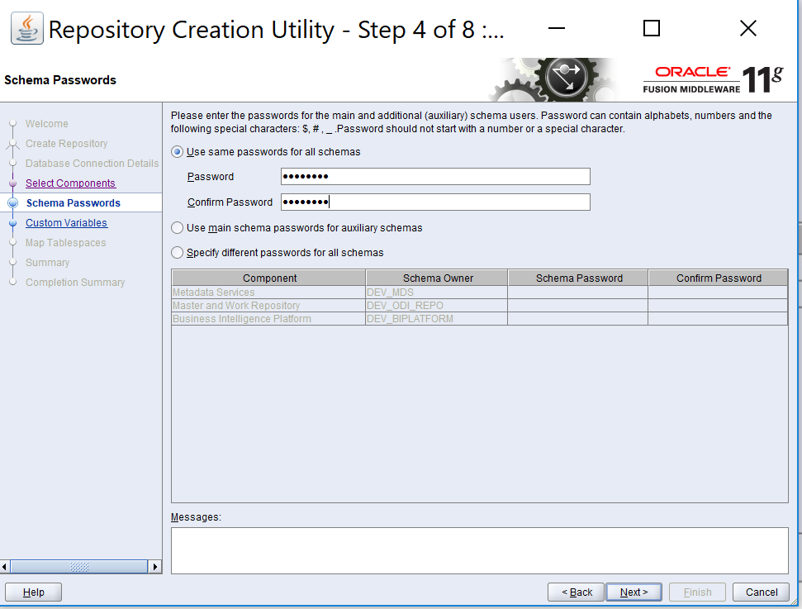

**RCU: Now** assign the following **Custom Variables and Values**

**Supervisor Password:** welcome1

**Work Repo Password:** welcome1

**Work Repo Type:** D

|  |  |
| --- | --- |
| Work Repository Type | Specify how the Work Repository will be used:  Use **Development (D)** for creating a development repository. This type of repository allows management of design-time objects  such as data models and projects (including interfaces, procedures, etc.)  A development repository also includes the run-time objects (scenarios and sessions). This type of repository is suitable for  development environments.  Use **Execution (E)** for creating an execution repository: This type of repository only includes run-time objects  (scenarios, schedules and sessions). It allows launching and monitoring of data integration jobs in Operator Navigator.  Such a repository cannot contain any design-time artifacts. Designer Navigator cannot be used with it.  An execution repository is suitable for production environments. |

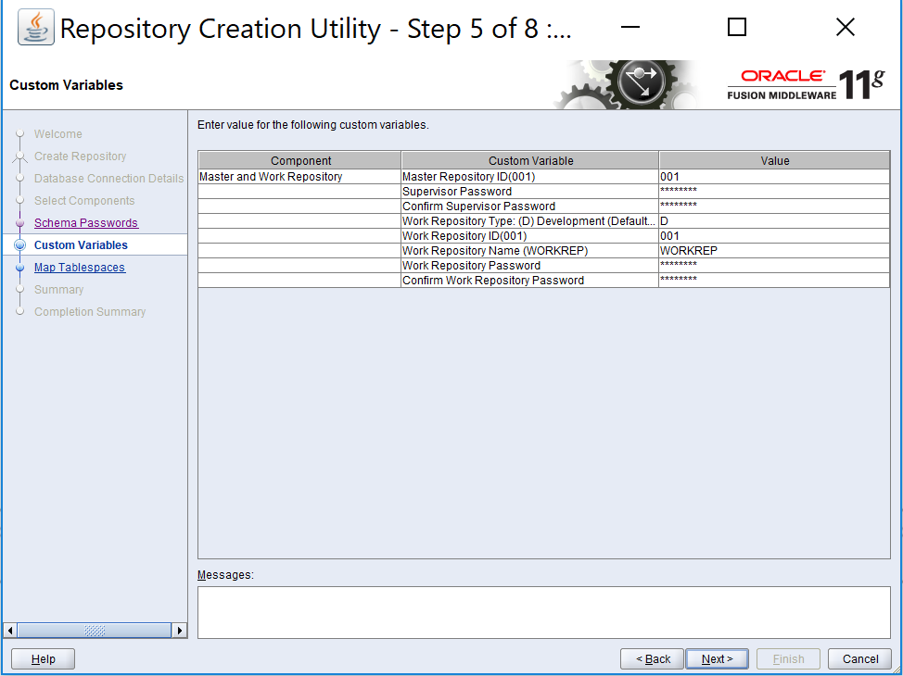

Click Next

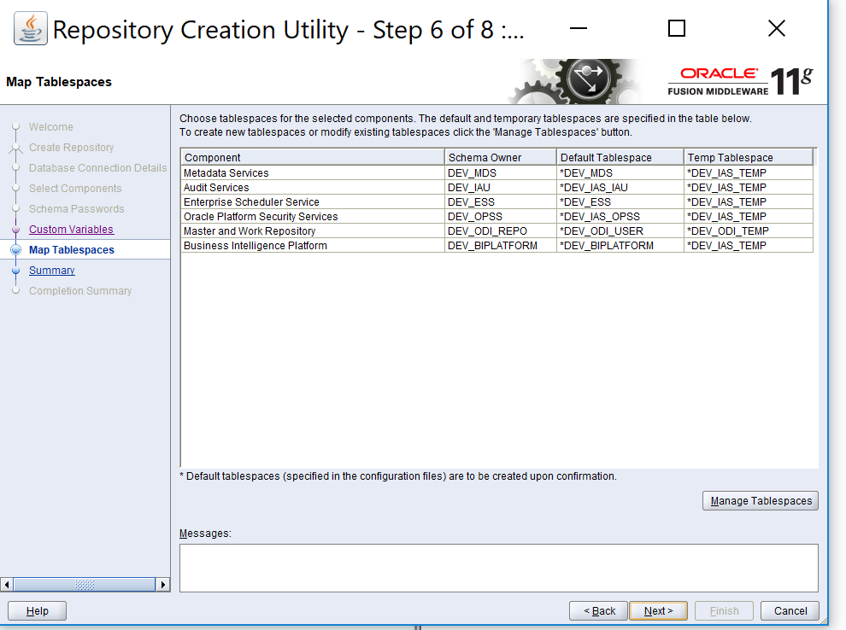

**Completed RCU installation:** Below are the details

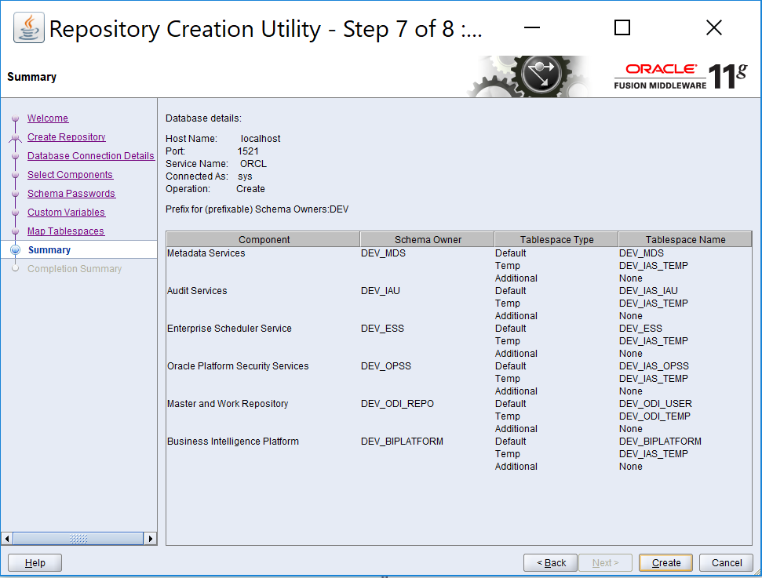

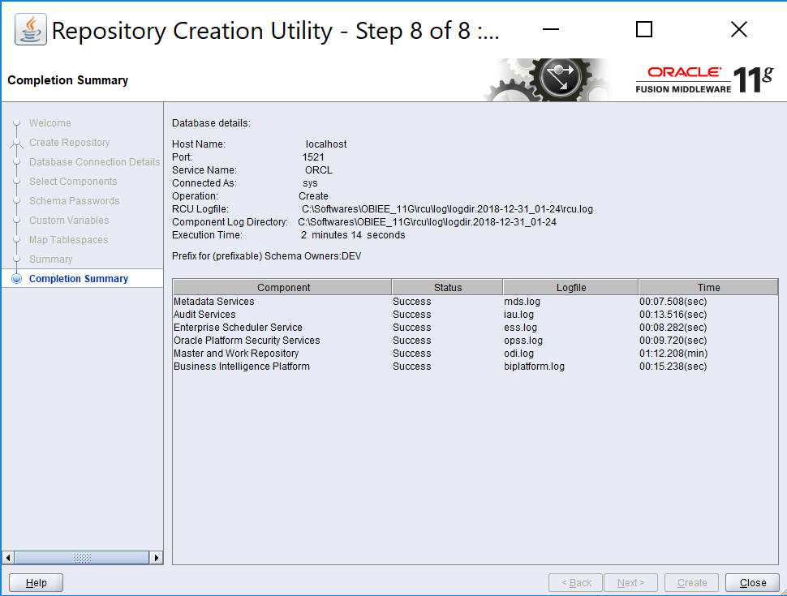

**Note: RCU documentation:** [**https://docs.oracle.com/middleware/1212/core/RCUUG/rcu_screens.htm#RCUUG227**](https://docs.oracle.com/middleware/1212/core/RCUUG/rcu_screens.htm#RCUUG227)

**------------------------------------------------------------------------------------------------------------------------------------------------------------------------------------------------------------------------------------------------------------------------------------**

**OBIEE 11g Installation**

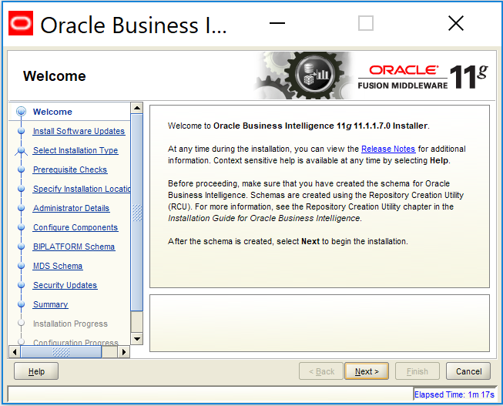

Skip the software updates

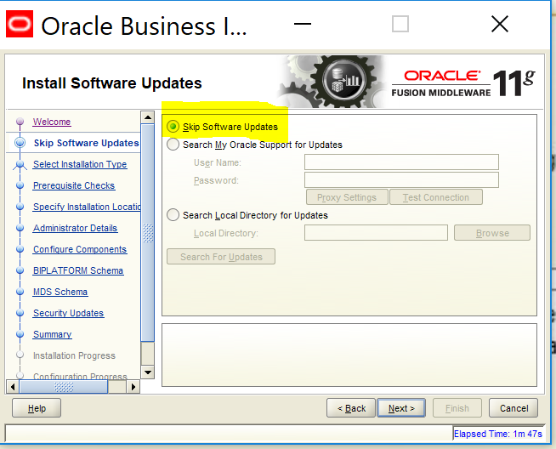

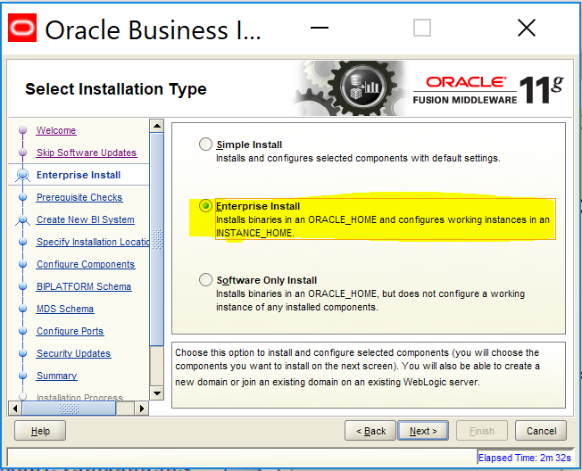

**Note Change the Version Value if you are using the Latest version of Windows OS**

**Issue:  
OBIEE 11g 11.1.1.7.0 was recently certified on Windows Server 2012 64-bit. When installing, the pre-requisite check for the Operating System fails.**

Cause:  
The software is certified; however, the Oracle Installer is not yet updated to reflect the certification. This can sometimes occur when a certification happen post software release.

**Resolution:**

**You can resolve this error by updating the pre-requisite check file in the install media.  
Step 1:**Navigate to where you have unzipped, with 7-zip, the OBIEE 11g (11.1.1.7.0) installation media (locally or on a mount).  
**Step 2:**  
Backup the following file:  
[media mount]\bishiphome\Disk1\stage\prereq\win64\refhost.xml

**Step 3:**  
Update the refhost.xml file to add the new operating system at the end of the certified systems section  
OPERATING_SYSTEM>  
<VERSION VALUE=”6.2″/>  
</OPERATING_SYSTEM>

For example:  
<CERTIFIED_SYSTEMS>  
<!– <OPERATING_SYSTEM>  
<VERSION VALUE=”5.1″/>  
<SERVICE_PACK VALUE=”2″/>  
</OPERATING_SYSTEM>  
<OPERATING_SYSTEM>  
<VERSION VALUE=”5.2″/>  
<SERVICE_PACK VALUE=”2″/>  
</OPERATING_SYSTEM>  
<OPERATING_SYSTEM>  
<VERSION VALUE=”6.0″/>  
<SERVICE_PACK VALUE=”1″/>  
</OPERATING_SYSTEM>  
<OPERATING_SYSTEM>  
<VERSION VALUE=”6.1″/>  
</OPERATING_SYSTEM>  
<OPERATING_SYSTEM>  
<VERSION VALUE=”6.2″/>  
</OPERATING_SYSTEM>  
</CERTIFIED_SYSTEMS>  
….  
**Step 4:** Save the file  
**Step 5:** Re-start the Installer to re-start and complete the install.  
**Step 6:** The installer will then proceed without the error

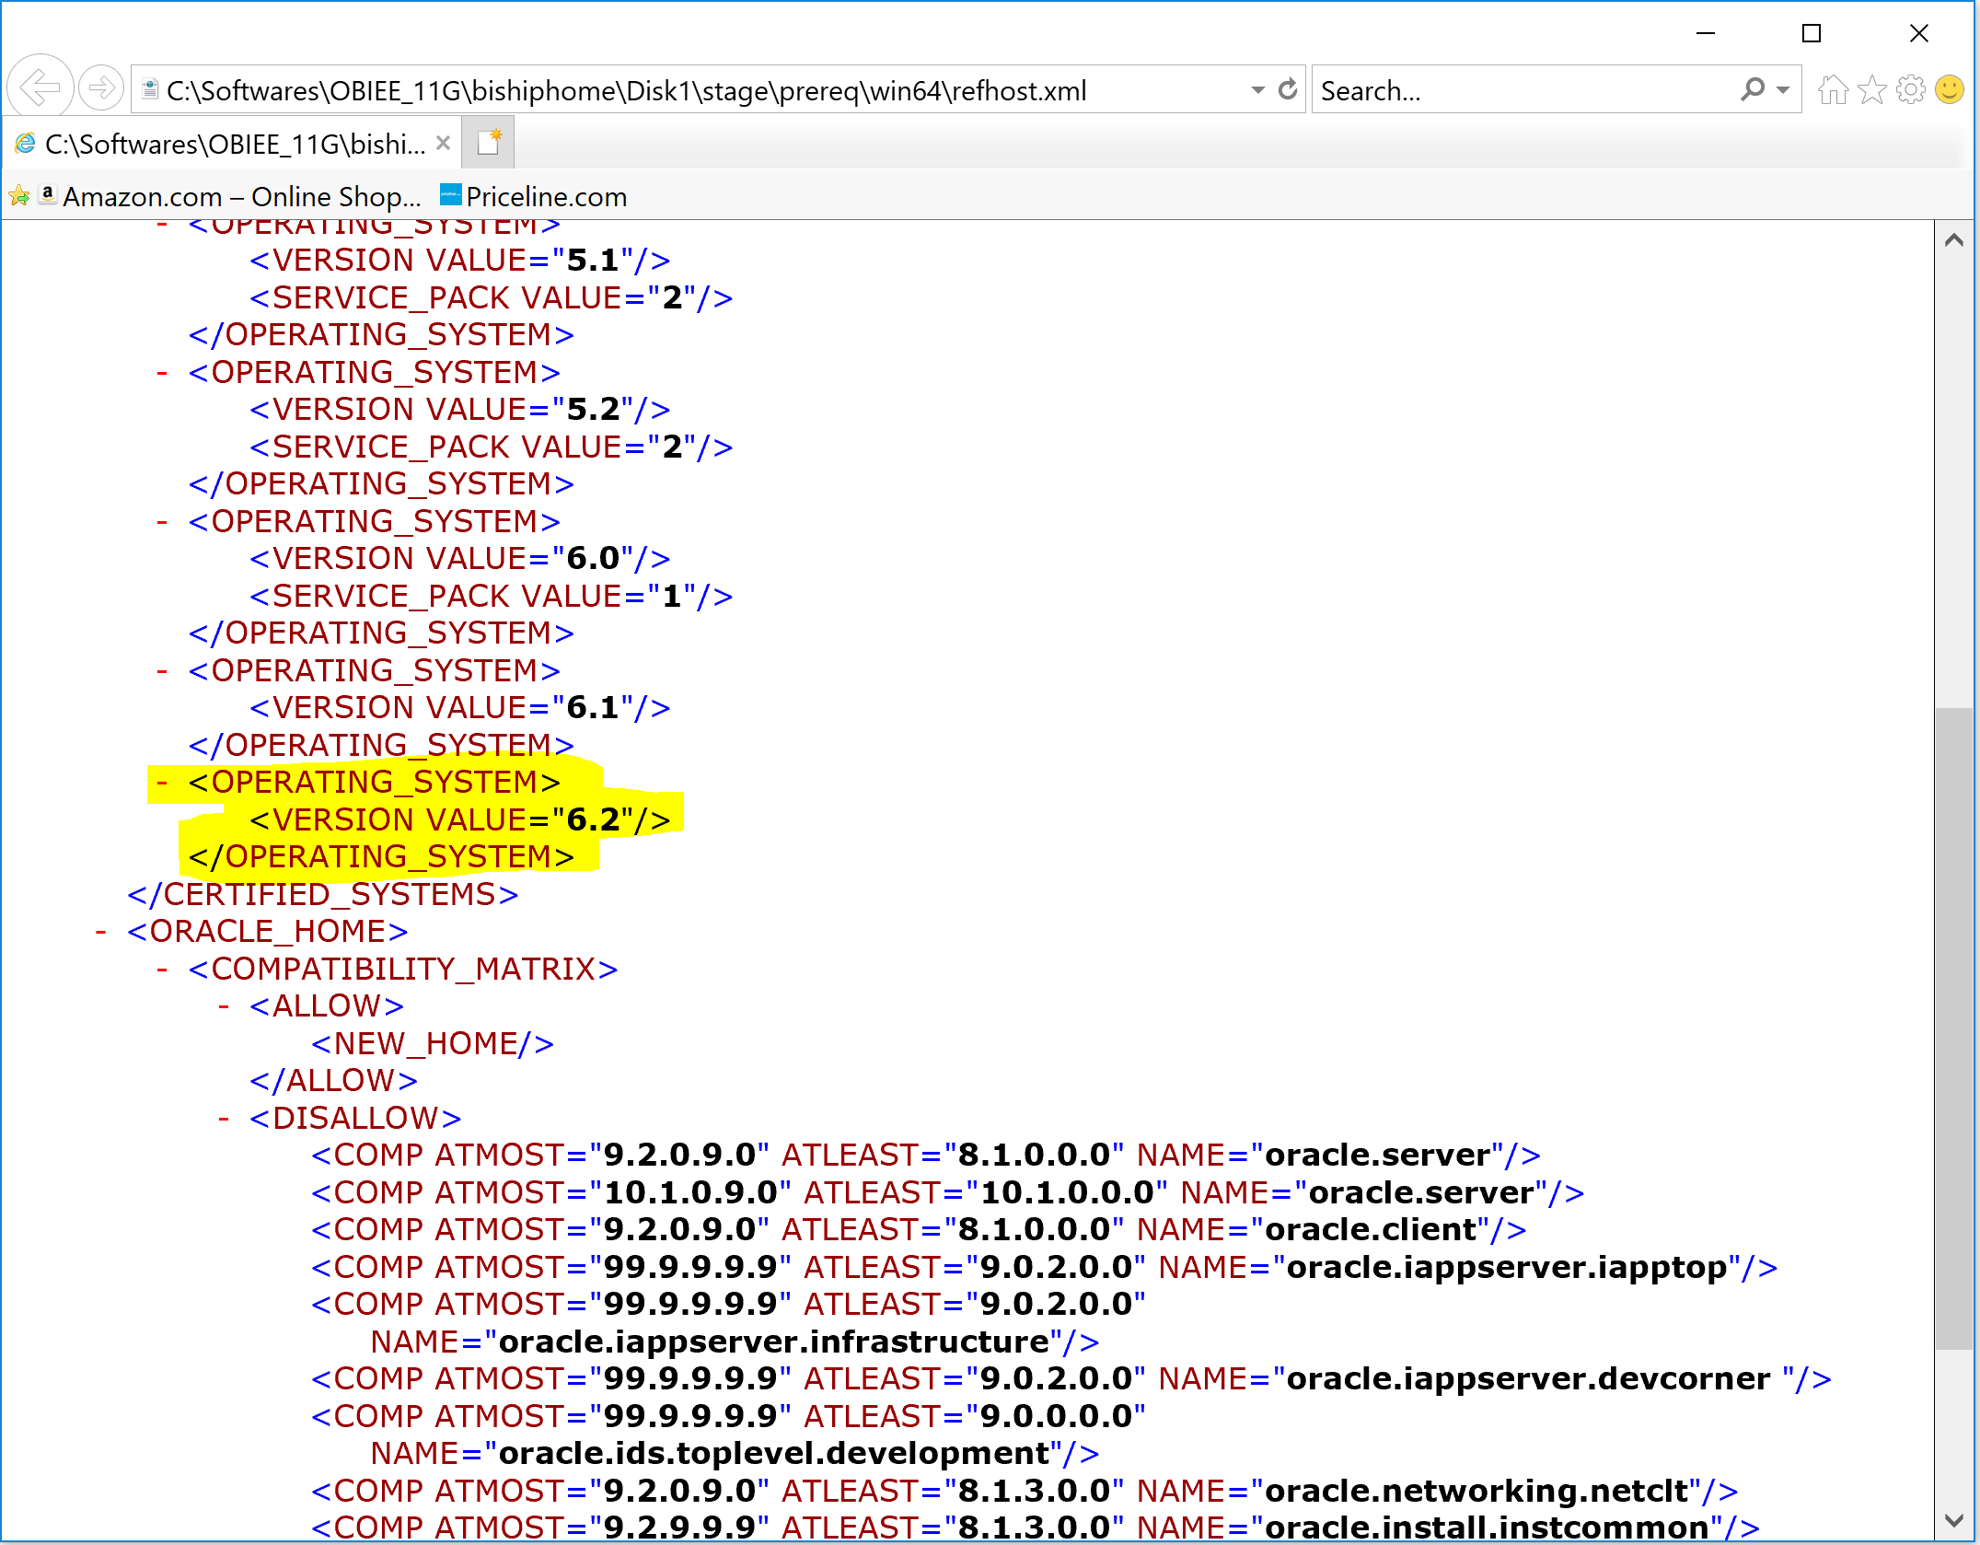

And Run directly from : C:\Softwares\OBIEE_11G\bishiphome\Disk1\install\win64 🡪 Setup file

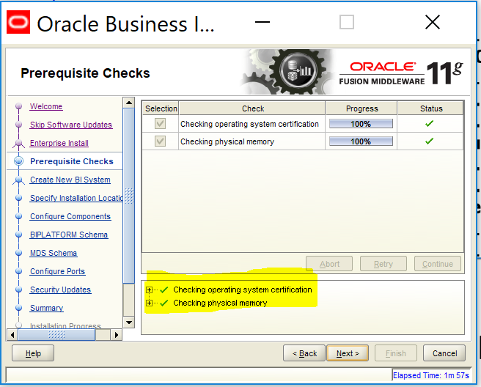

**Now if we want to Scale out check the given box and give the required arguments**

**Here** New BI System

User Name: weblogic

Password: weblogic123

Domain Name: bioundation_domain

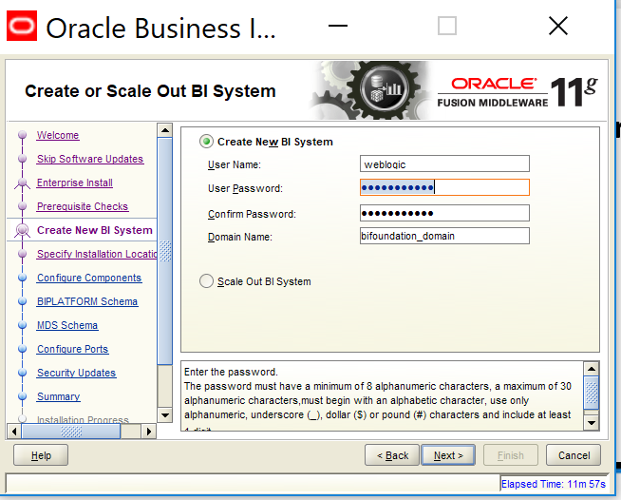

**Enter the location where you would like to install the Middleware. Click Next.**

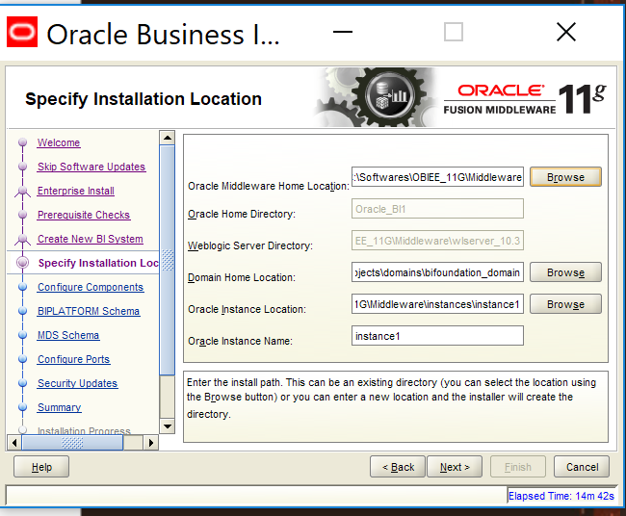

**Click Next to install**

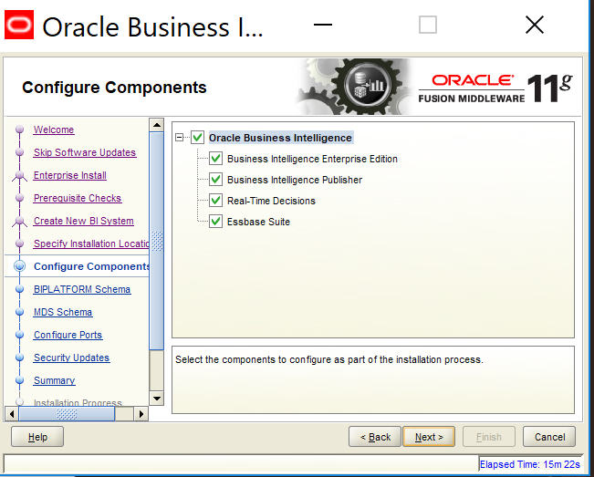

**You can select Auto Port Configuration or if you would like to manually enter the ports. then you would have to create ini file and select the file.**

**I choose Auto Port Configuration. Click Next.**

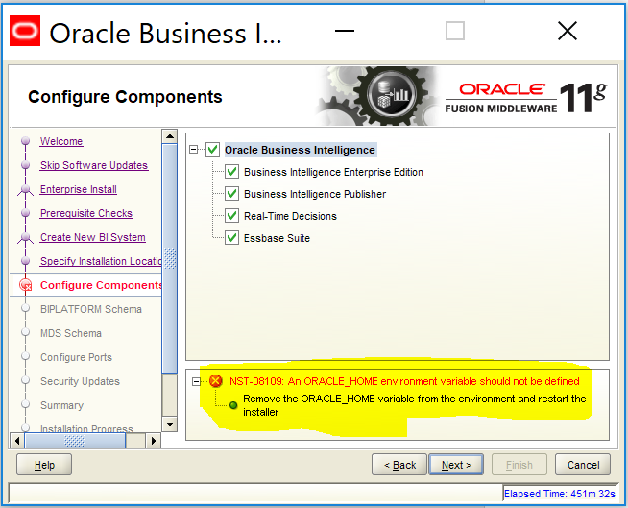

**Now delete the Environmental Variable Oracle_Home and restart the installer!**

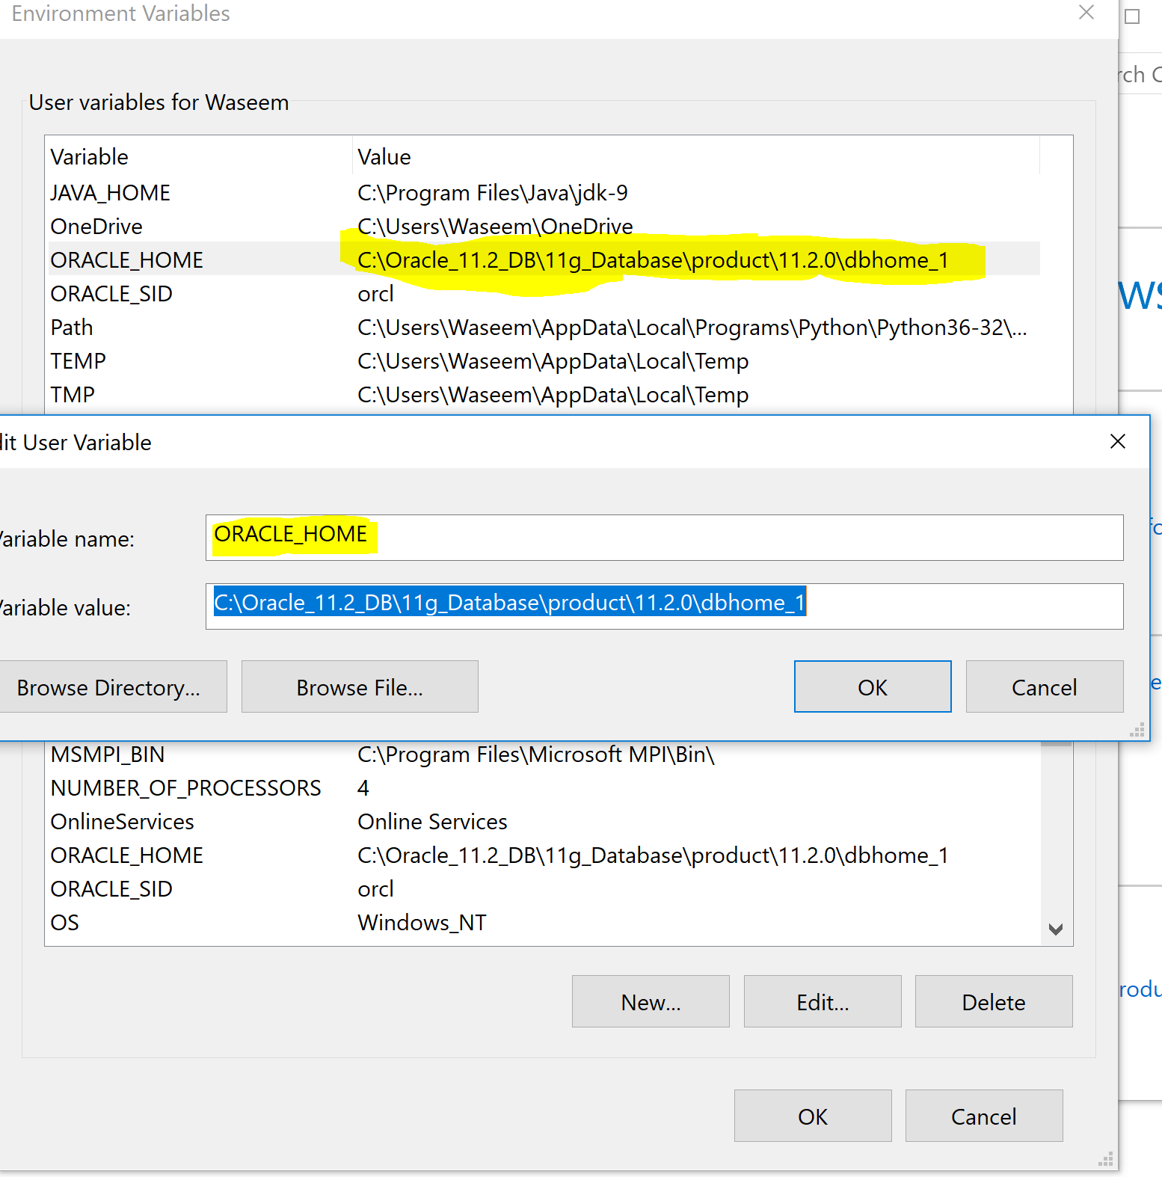

Variable Name: ORACLE_HOME

Variable value: C:\Oracle_11.2_DB\11g_Database\product\11.2.0\dbhome_1

**Now it continues..**

Give the Connect String as shown below and

BIPLATFORM Schema Username: DEV_BIPLATFORM

BIPLATFORM Schema Password: welcome1

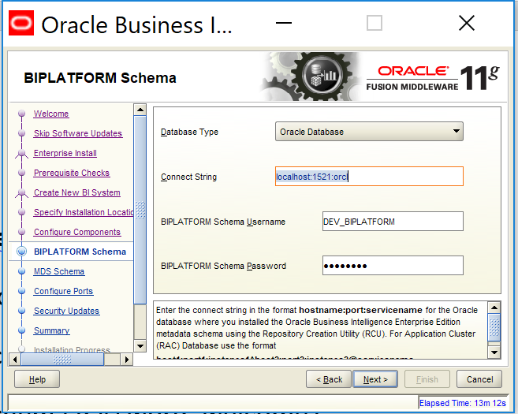

**Give the same credentials to DEV_MDS (Meta Data services)**

Enter the connect string in the format **hostname:port:servicename** for the Oracle database where you installed the Oracle Business Intelligence Enterprise Edition metadata schema using the Repository Creation Utility (RCU). For Application Cluster (RAC) Database use the format **host1:port1:instance1^host2:port2:instance2@servicename**.

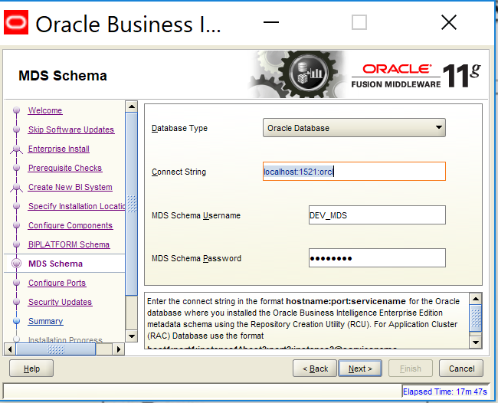

**You can select Auto Port Configuration or if you would like to manually enter the ports. then you would have to create ini file and select the file.**

**I choose Auto Port Configuration. Click Next.**

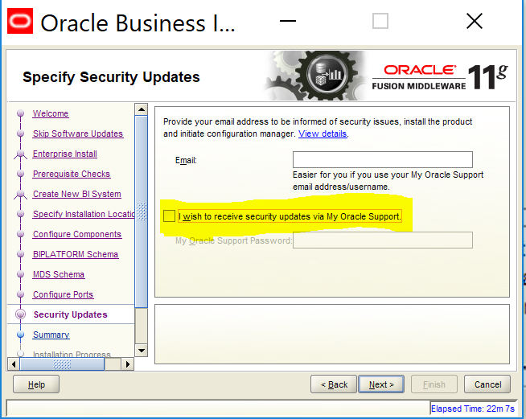

**I skipped the secutiry updates (which is not recommended by oracle)**

**Next: You will get to the summary of installation. Click Install**

**Note: Better to save the summary file in a desired location, for future references**

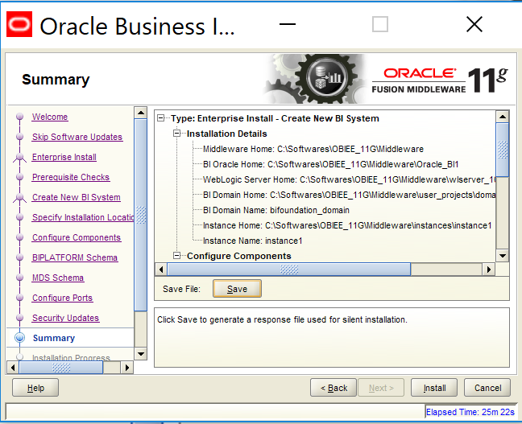

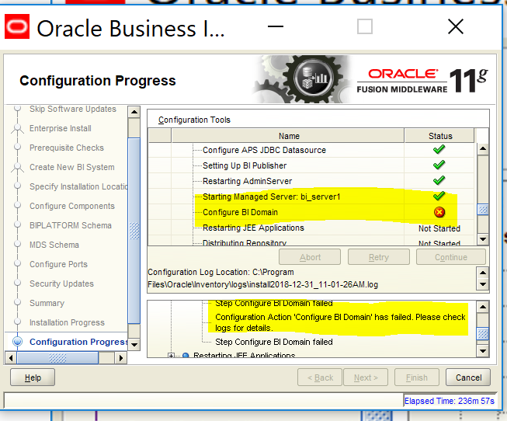

**Steps to perform:**

1. Change the actual IP given i.e localhost to physical IP.
2. Ping IP of the Machine (LAPTOP-9C3TR4US) this has to return when “ping localhost” in cmd

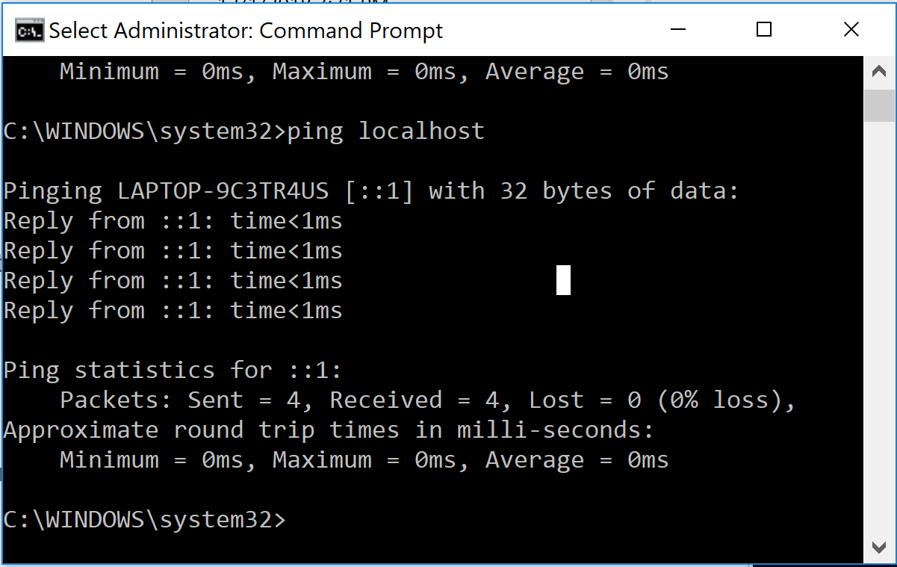

1. Please check TNSNAMES.ORA and LISTNER.ORA files and replace ‘localhost’ with host name ‘LAPTOP-9C3TR4US’.

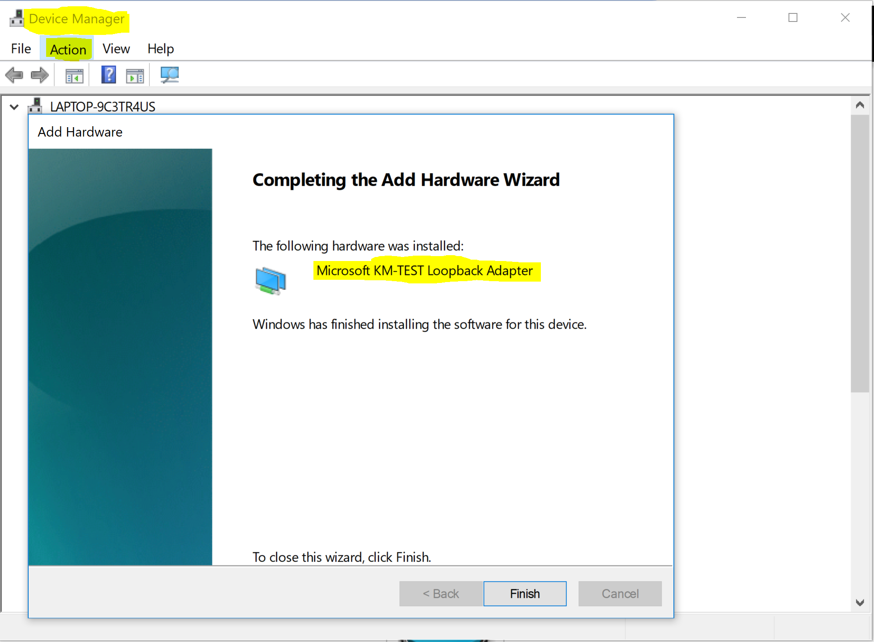

**CMD commands:**

Listener commands : Lsnrctl status / start / stop / service

OPMN commands: opmnctl startall / stopall

EMNCTL commands: emctl start oms / stop oms

Windows IP Configuration: ipconfig /all

Ping the required IP address and port to respond

Check for errors using:

TNS service check: tnsping orcl

Verify with the following commands:

Lookup for a specified Machine name: nslookup <Machine Name/IP address>

